GROUP Roster Example in Planning Center
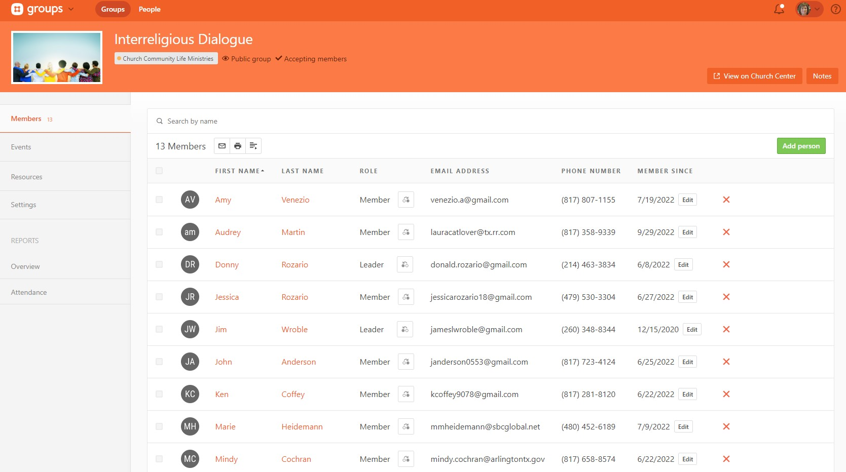
Where to find Leaders Resources in the GSCC Leaders GROUP in Planning Center
